A Scenario in Cartograf
(This document was created by Sophie Lussier, LBPSB)
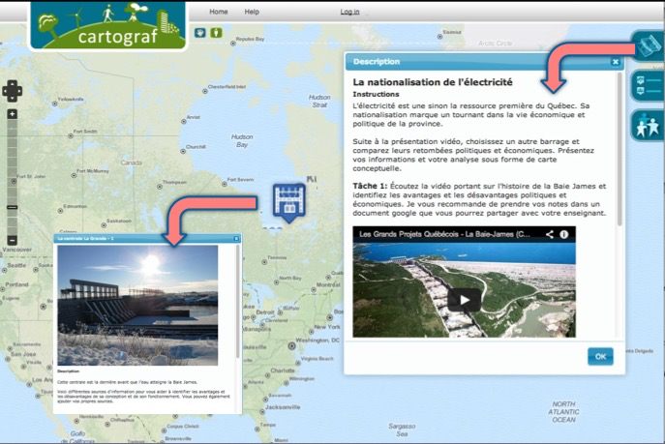
What are the essential elements of a scenario?
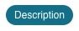
- Create a new MAP and give it an appropriate title for your scenario.
- Teacher / student: either can access, duplicate and edit the scenario and its instructions. Note that instructions can be written right in the MAP tab’s Description area, OR in appropriate icons or shapes.
- In your instructions, include a brief summary of the unit, the territory, the time period, the theme, etc.
- Provide a short overview of the learning goals or purpose of the scenario, and a preview of the tasks
Mention any intellectual operations you will be covering. (For example, situate in space and time!)
- Procedure: Provide the task details for your students to complete, now with more specific instructions. Include suggestions for which Cartograf tools to use, and refer to any other resources. It is also a good idea to include an example of what you want students to complete for each task. (Ex. A sample point)
Try to separate task sections according to the intellectual operations when possible.
Note that some tasks can be completed outside of Cartograf. (ex. On a graphic organizer.)
- What to do with the mapping scenario?
You can of course display your map with a projector and use it to teach, for class discussion, etc.
Or you can distribute it via the Share link tab options, so students can duplicate it, edit it, collaborate using it, create their own new maps, etc.

- Resources: Documents, images and media (Youtube videos) can be displayed within Cartograf. However, you can also provide additional links to websites, or other pictures and documents, by adding them to the map description, in the points-of-interest descriptions, or even in shapes and lines on the map.
- Evaluation: Make links to any external rubrics or evaluation criteria. (Questions, forms, grids, etc.). You can also add text questions within the point/line descriptions that students can open answer.
Advanced users may discover it is actually possible to upload and link Word documents.

