Montreal, a metropolis

This learning scenario must be used with the application https://cartograf.learnquebec.ca/

As a large metropolis in Quebec , Montreal concentrates nearly half of the province's population in its whole urban region, which has 4.2 million inhabitants! The island of Montreal alone has 1.6 million inhabitants. As the second largest Canadian metropolis, Montreal is only surpassed in size by Toronto, which has more than 5.9 million inhabitants.
A metropolis is a great economic, cultural and political center. It is also a city where there is a high concentration of population.

1- Before starting

1 - Identify the limits of the Island of Montreal.
2 - Identify the main infrastructure of the city, airport, bridges serving the city, highways and train stations.
If while looking at the map you feel a little lost, you can click on the icon to return to the original map.

2- Task

1 - Select the satellite image as the base map

2 - Here is a list of sites to identify. Using the indications provided, you must find them on the satellite image and identify them by placing a marker.

- a green space: There are several on the Island, such as Mount Royal (in the center) or one of the many large parks ;
- the port of Montreal: on the riverbank, in the central-eastern part of the city. You can find it thanks to the distinctive shapes of the docks;
- the downtown: It can be recognized by its skyscrapers and is located east of Mount Royal.;
- an industrial district: industrial spaces are characterized by large buildings (factories and warehouses). They are located on the outskirts of the city center (eastern and western ends of the island).;
- a residential area : identify a residential neighborhood on the island of Montreal. See the list of Montreal boroughs.

3 - For each marker:
- use the "Panorama" (streetview) function to search and identify a distinctive landscape of the area you are examining. Once you have found your view on that landscape, you can then click on "Add Marker". ;
- in the marker's description box, specify at least 3 elements that characterize this type of territory (observe buildings, roads, cars, vegetation, etc.).;
- choose an icon and don't forget to complete your legend.

Click to access the map:
Create your copy of the Montréal, a metropolis map by clicking on .
You can access the instructions directly on the map by clicking on .

References :

Article Wikipédia sur Montreal

Metropolises PDFs of original docs for Montréal

Dossier sur montréal du RÉCIT univers social

Dossier Allo Prof les métropoles

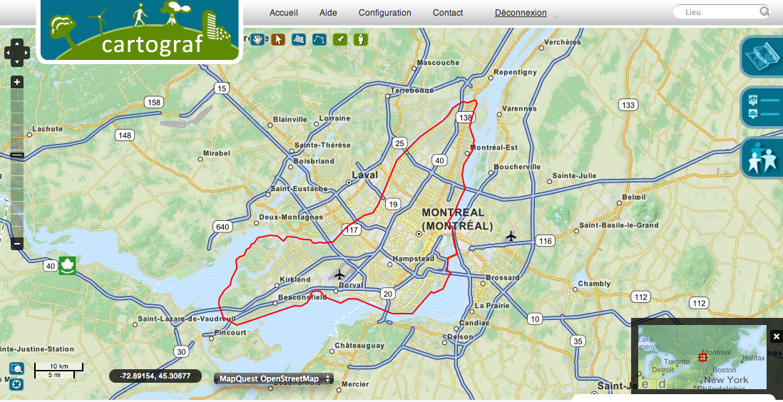

The complete map and its geolocated content is available on cartograf.recitus.qc.ca

